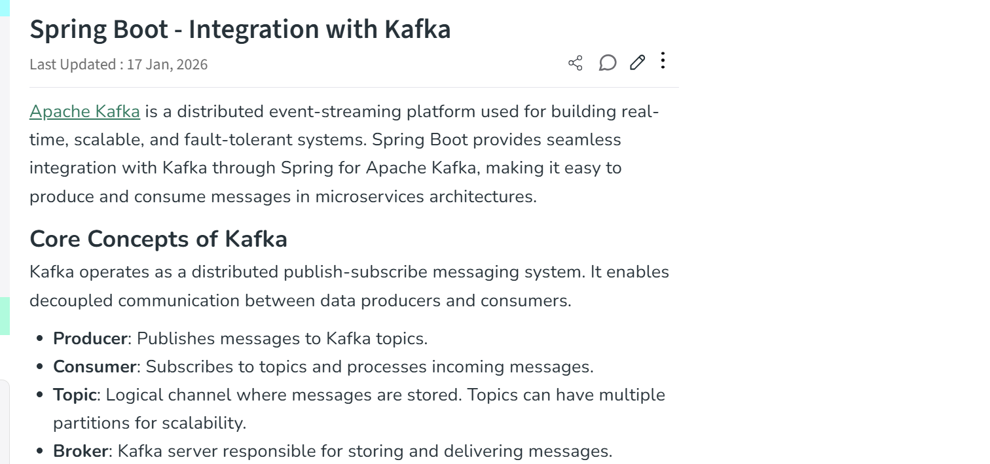
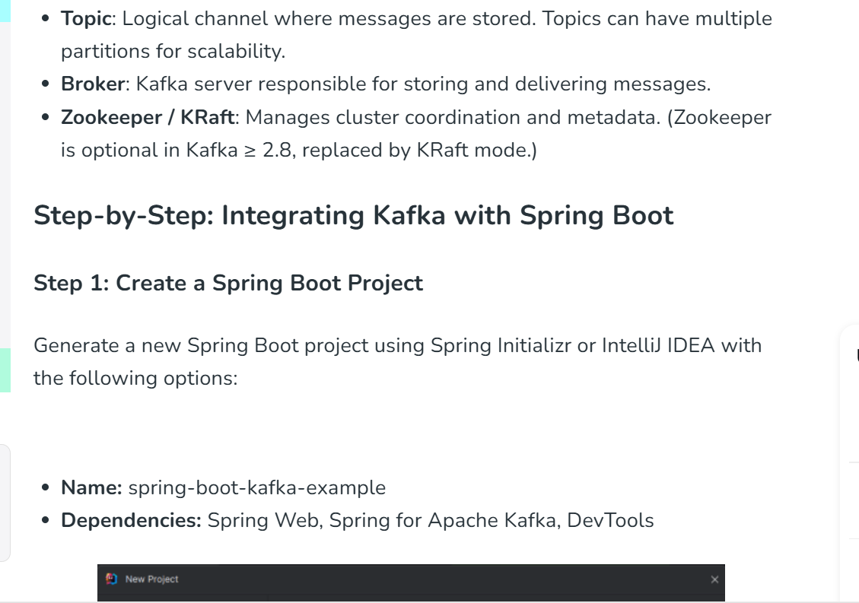
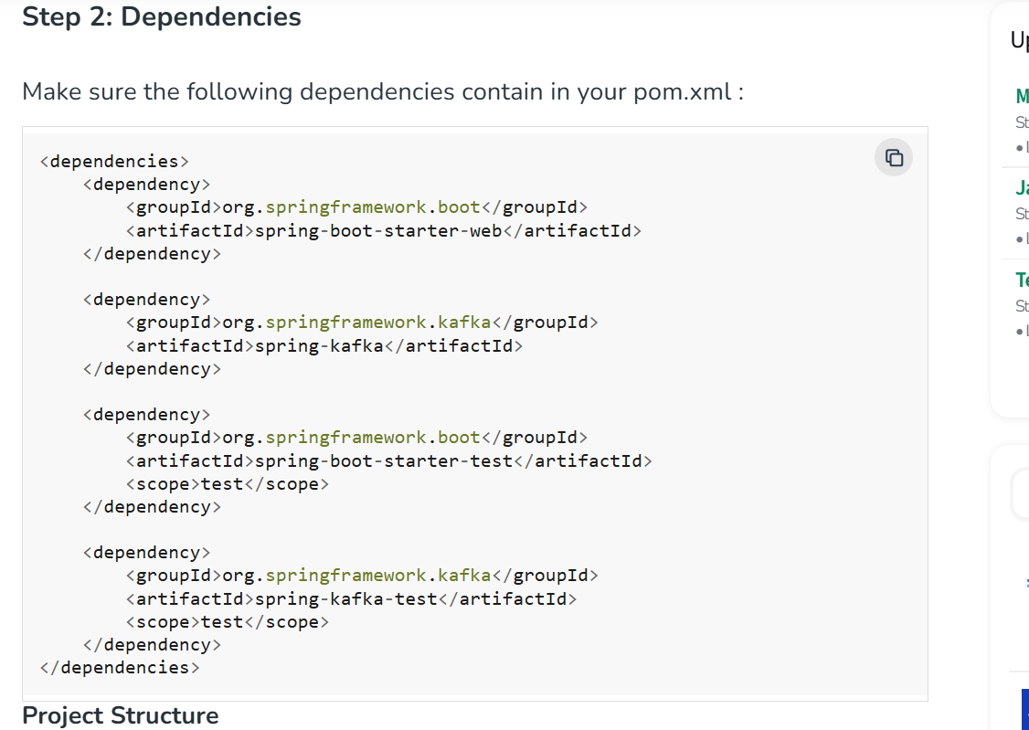
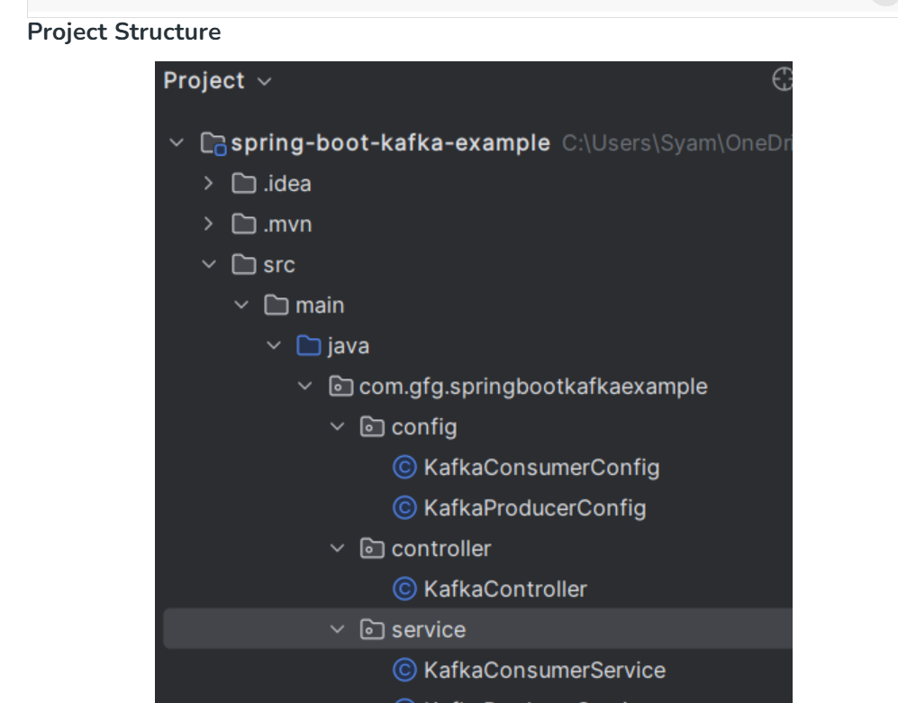
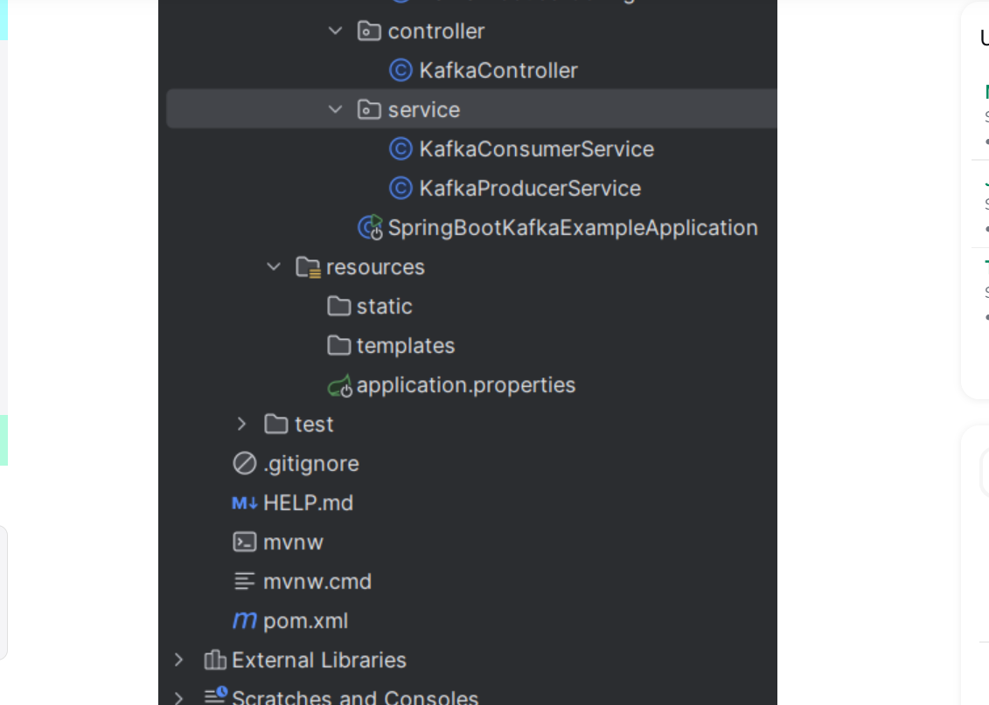
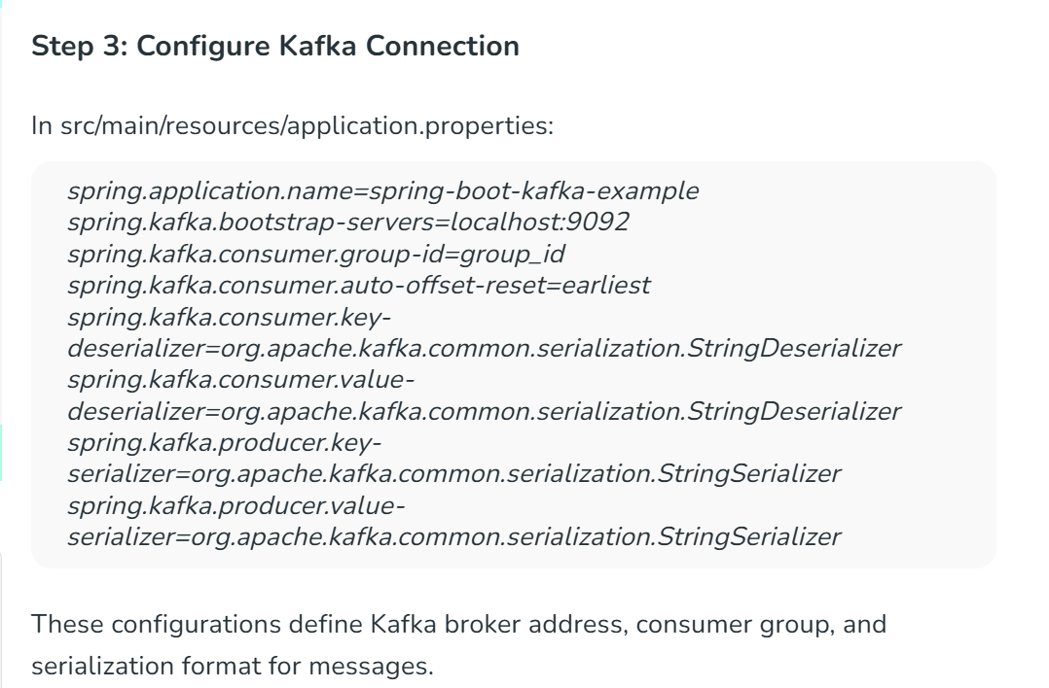
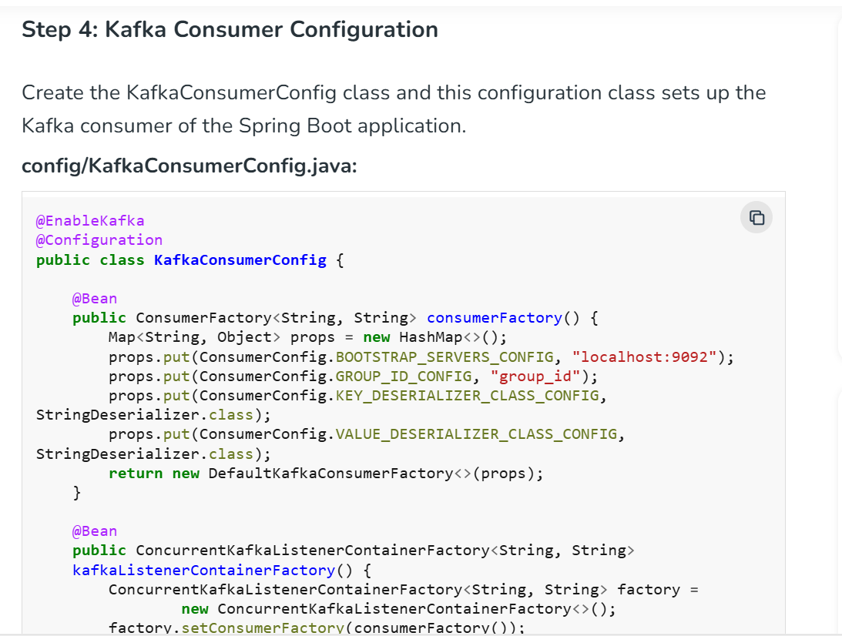
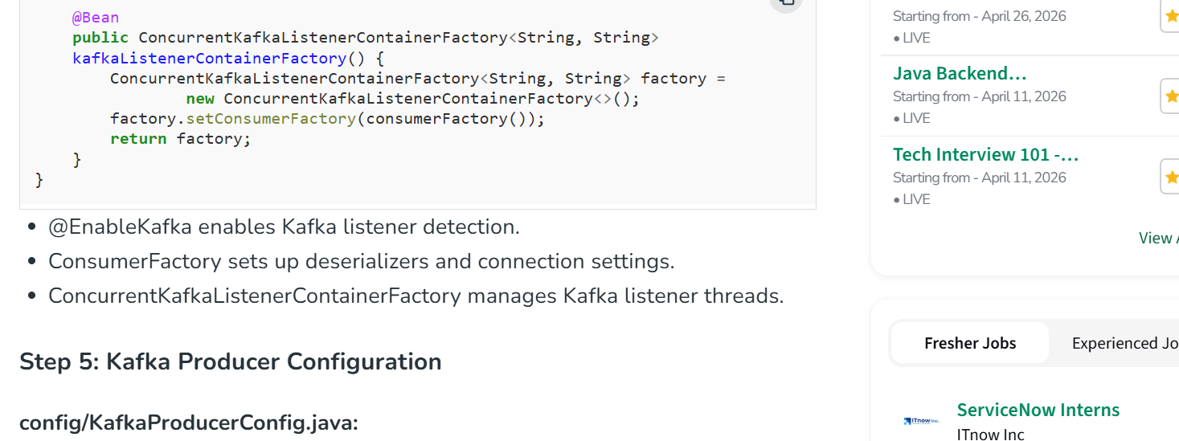
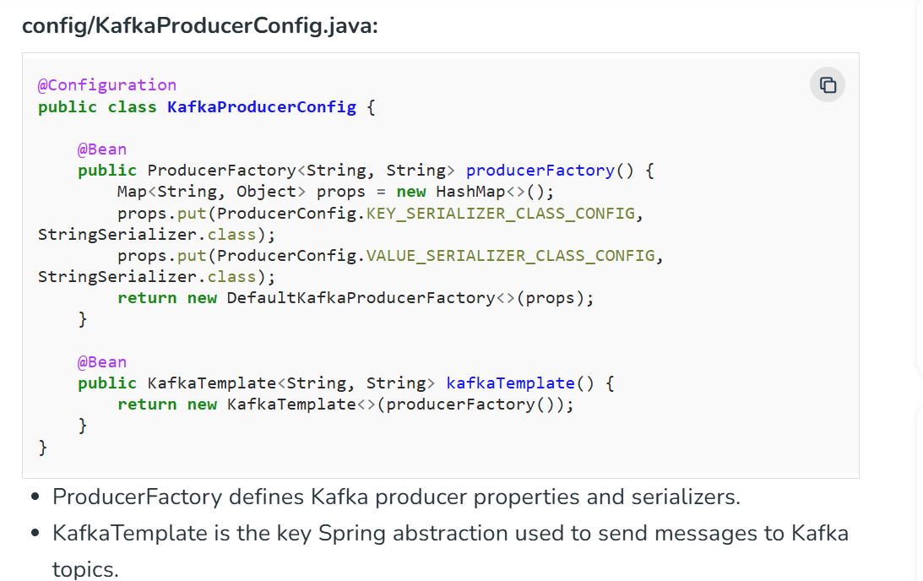
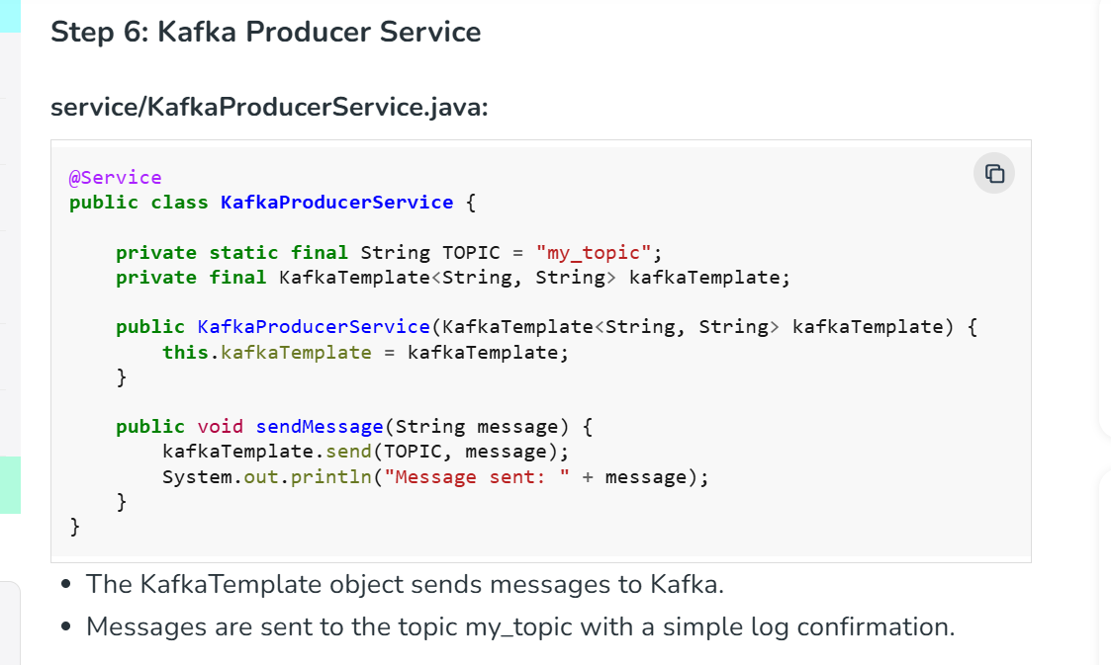
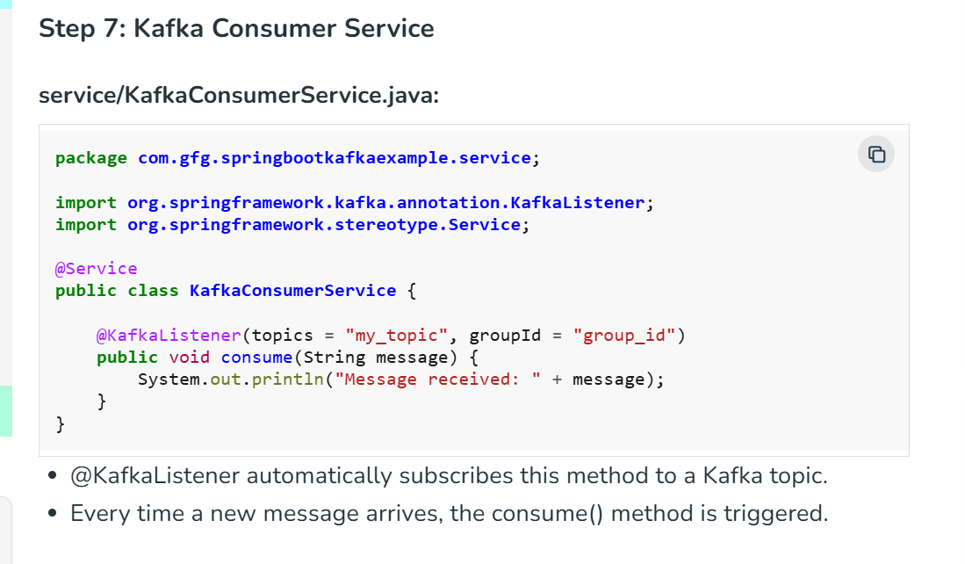
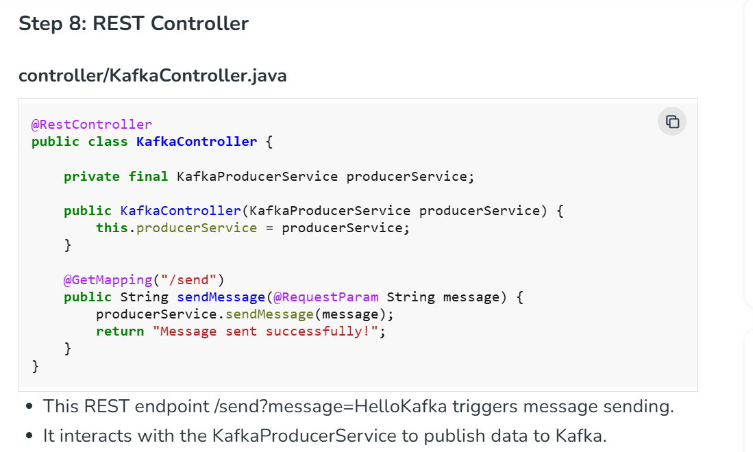
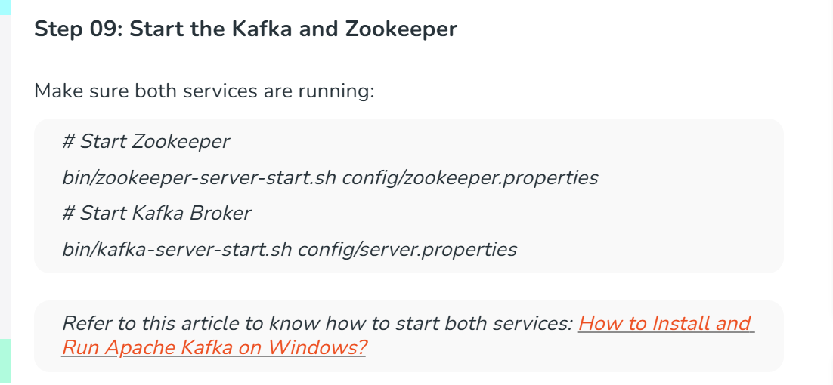
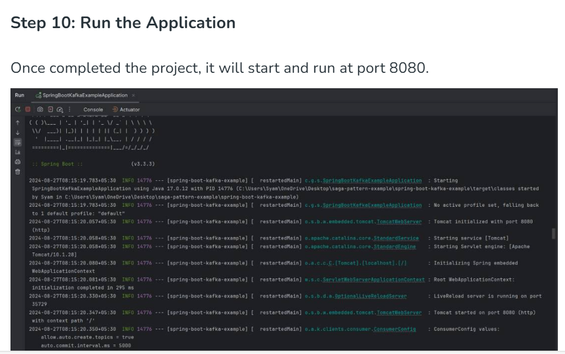
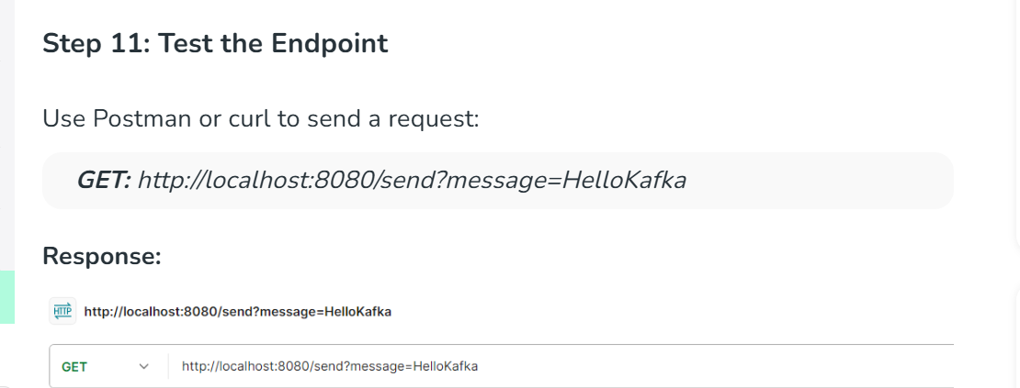

How to Install and Run Apache Kafka on Windows?
Last Updated : 15 Jul, 2025

Apache Kafka is an open-source application used for real-time streams for data in huge amount. Apache Kafka is a publish-subscribe messaging system. A messaging system lets you send messages between processes, applications, and servers. Broadly Speaking, Apache Kafka is software where topics can be defined and further processed.

Downloading and Installation
Apache Kafka can be downloaded from its official site kafka.apache.orgFor the installation process, follow the steps given below: Step 1: Go to the Downloads folder and select the downloaded Binary file. Step 2: Extract the file and move the extracted folder to the directory where you wish to keep the files. Step 3: Copy the path of the Kafka folder. Now go to config inside kafka folder and open zookeeper.properties file. Copy the path against the field dataDir and add /zookeeper-data to the path.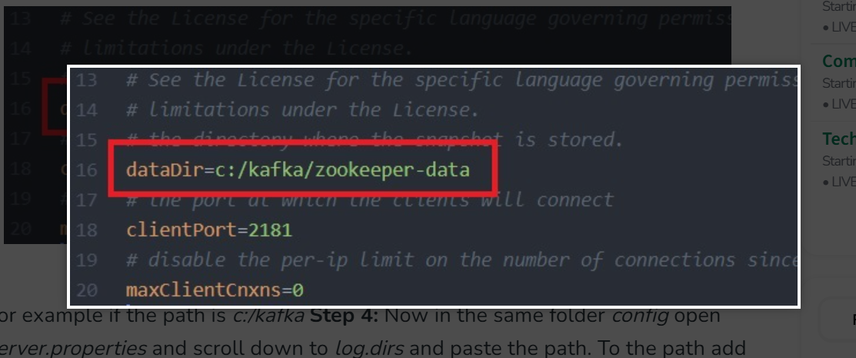For example if the path is c:/kafka Step 4: Now in the same folder config open server.properties and scroll down to log.dirs and paste the path. To the path add /kafka-logs Step 5: This completes the configuration of zookeeper and kafka server. Now open command prompt and change the directory to the kafka folder. First start zookeeper using the command given below:
.\bin\windows\zookeeper-server-start.bat .\config\zookeeper.properties
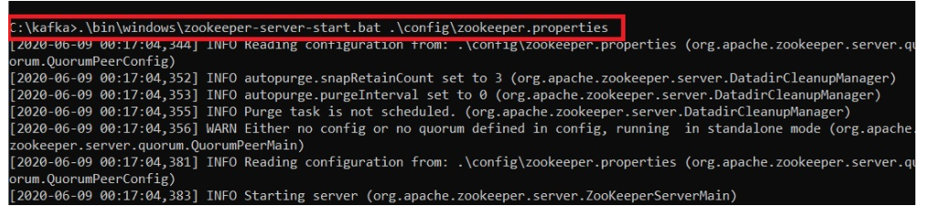Step 6: Now open another command prompt and change the directory to the kafka folder. Run kafka server using the command:
.\bin\windows\kafka-server-start.bat .\config\server.properties
Now kafka is running and ready to stream data.
